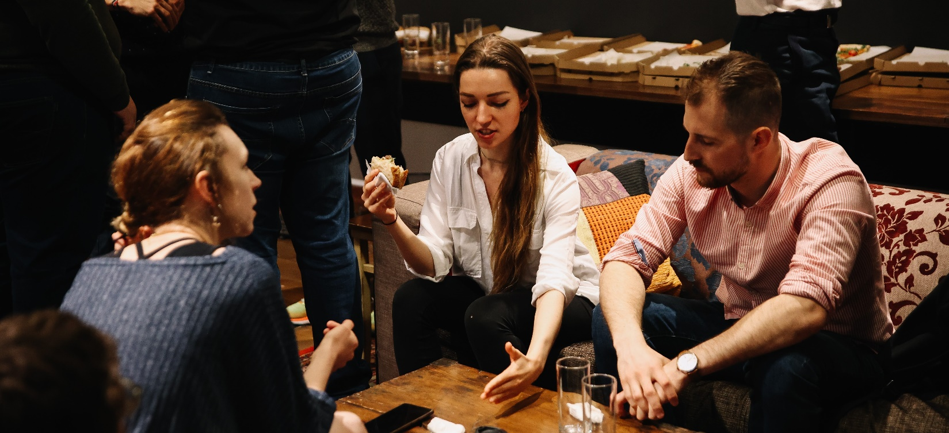
Design Terminal Mentoring Program
Onepager template

Application criteria

For you to get selected for the program you need:

- a finished, or almost finished prototype

- a business that targets the international market

- a team with at least two people who are determined to work full-time on the project

- 1-2 team members who can dedicate their time for the entire length of the program

- a founding team with sufficient business and technological expertise

- bonus point if your startup solves a social issue

Guide to preparing a business concept

On the following page, you will find a template and guide on how to create a one-pager for your business. Your task is to prepare a business concept by filling out the spaces provided in the template, and then convert it o PDF for submission. Please keep your application document to 1 page!
For a successful application, you must also fill out the application form by clicking the „Apply” button on the program’s website.

If you have any questions you can contact us at mentor@designterminal.org .

Presentation of the business idea in one sentence/line (one-liner)

Email: sample@xyz.hu
Name: Sample Sarah
Project Name
logo
Picture of your product, or a picture that helps us understand your product/service.

Phone: +12 34 567 8912

The problem
Explain the problem you are solving and whose problem you are solving! Summarize in 1-2 sentences!

Target market
Describe the target market of your idea, how big the market is currently and who would be your customers. Summarize in 2-3 sentences maximum!

The solution
Describe your product/service, why it is useful and how it could benefit society. Summarize in 2-3 sentences maximum!

Competitors
Introduce your competitors, what are the current solutions to the problem. Summarize in 2-3 sentences maximum!

Competitive advantage
Describe your main differentiating features, what it is that you can innovate compared to others. Summarize in 2-3 sentences maximum!

Business model
Describe how would your company work, how you plan on making money. Summarize in 2-3 sentences maximum!
E.g: A subscription-based company that sells a product or service on recurring, ongoing basis. The income comes from regular, monthly subscriptions.
Industry: Explain in one word!
Current status:
Where is the product/service development now?
Next steps:
What you want to achieve during the program and where you want to be by the end of it?

Sources:
What resources would you need to reach the next level?

Creator of the idea



Team description
If you have a team, introduce them! How many of you there are, what roles they fill and how they contribute to developing the product/service. If you don’t have a team, leave this part empty.
xxx
The competence and role of the idea owner/founder

